***MDSC -103 ASSIGNMENT***

***PAVAN PYLA***

***22232***

Question B)

Outdoors, Inc has, as one of its product lines, lawn furniture.

They currently have three items in that line: a lawn chair, a standard bench, and a table. These products are produced in a two-step manufacturing process involving the tube-bending department and the welding department. The time required by each item in each department is as follows:

|  |  |  |  |  |
| --- | --- | --- | --- | --- |
|  | Product | | | Present Capacity |
| Lawn Chair | Bench | Table |
| Tube Bending(hrs) | 1.2 | 1.7 | 1.2 | 1000 hrs. |
| Welding(hrs) | 0.8 | 0 | 2.3 | 1200 hrs. |
| Tubing | 2 | 3 | 4.5 | 2000lbs |

The contribution that Outdoors, Inc. receives from the manufacture and sale of one unit of each product is $3 for a lawn chair, $3 for a bench and $5 for a table.

The company is trying to plan its production mix for the current selling season. It feels that it can sell any number it produces, but unfortunately production is further limited by available material, because of a prolonged strike. The company has on hand 2000 lbs. of tubing. The three products require the following amounts of this tubing: 2 lbs. per chair, 3 lbs. per bench, and 4.5 lbs. per table.

**Question and Answers:**

1. ***Formulate LP model for this problem?***

A.

We have to maximize the profit for seller with given constraints

Let

x1: no of Lawn chairs manufactured

x2: no of Bench's manufactured

x3: no of Table's manufactured

Then the LP problem goes like this

Maximize Z = 3x1 + 3x2 + 5x3

Subject to:

1.2 x1 + 1.7 x2 + 1.2 x3 <= 1000

0.8x1 + 0x2 + 2.3x3 <= 1200

2x1 + 3x2 + 4.5x3 <= 2000

X1, x2, x3 >= 0

1. ***Solve the problem by SOLVER?***

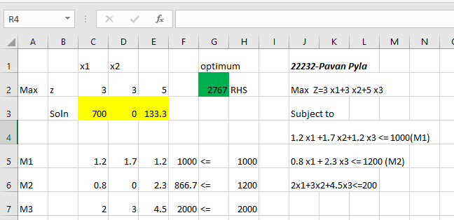

***3.What is the optimal production mix? What contribution can the firm anticipate by producing the mix?***

The optimal production mix is:

700 - Lawn chairs

0-Bence’s

133- Table's is the optimal mix

The firm can anticipate maximum profit than any other mix and the profit is 2767/-

4.what is the value of one unit more of tube bending time? Of welding time? Of metal tubing?

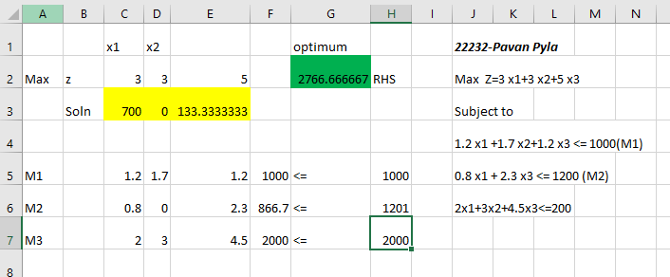

The one unit more of Welding has value **0**

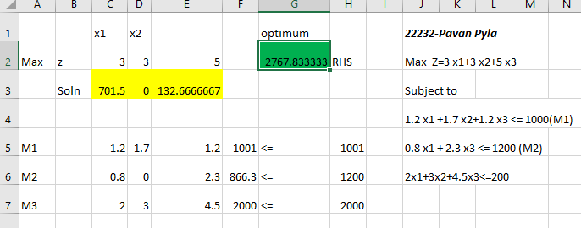

The one unit more of tube bending time is 2767.833333-2766.666667= **1.16666666666667**

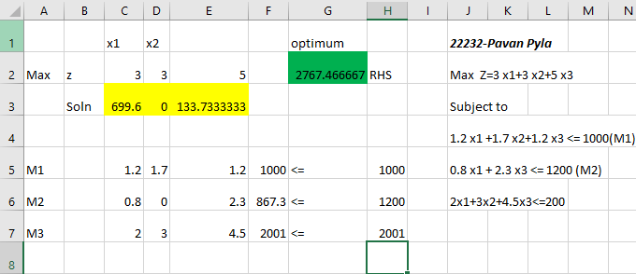

The one unit more of Tubing is 2767.4666667 -2766.666667=0.8

**We can justify this using the sensitive analysis from excel**

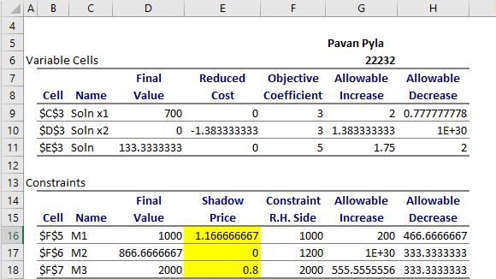

**5. *A local distributor has offered to sell Outdoors, Inc some additional metal tubing for $ 0.60/lb. Should Outdoors buy it? If yes, how much would the firm’s contribution increase if they bought 500 lbs. and used it in an optimal fashion?***

We know that the shadow price of the Tubing is **0.8** and the cost of the Tubing is 0.6 ,so there is **0.2/- profit for every 1lb Tubing.**

So it is advisable.

But the allowable increase is 555.555555556 so we can buy 500lbs

The profit is **500*0.2=100**

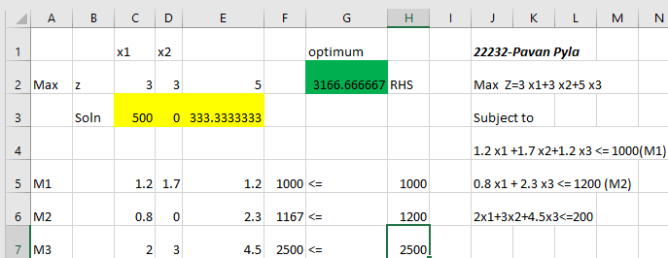

The total profit is **3166.666667** and amount we should pay to the seller is **500*0.6=300**

3166.666667-300=**2866.666667**

**6. *If Outdoors, Inc. feels that it must produce at least 100 benches to round out its product line, what effect will that have on its contribution?***

We need to add one more constraint

X2 >= 100 (M4)

If we include this in the simplex algorithm.

The solution is going to be infeasible

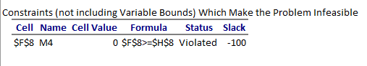

So , it is not recommended

***7.The R&D department has been redesigning the bench to make it more profitable. The new design will require 1.1 hours of tube-bending time, 2.0 hours of welding time, and 2.0 lbs. of metal tubing. If it can sell one unit of this bench with a unit contributing of $3, what effect will it have on overall contribution?***

If it can sell one unit of this bench with a unit contributing of $3 using these constraints then the

Optimal mix will be

**457: Chair’s**

**286: Benches**

**114: Table’s**

**We wil get the profit 2800/-**

Which is better than previous mix

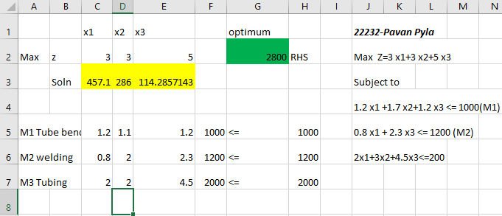

***9.Outdoors, Inc. has a chance to sell some of its capacity in tube bending at cost + $1.50 per hour. If it sells 200 hours at that price, how will this affect contribution?***

The shadow price of the Tubing is 0.8 and if it sells the tubing at price of 1.5$ then he will get 0.7$ per hour as profit .

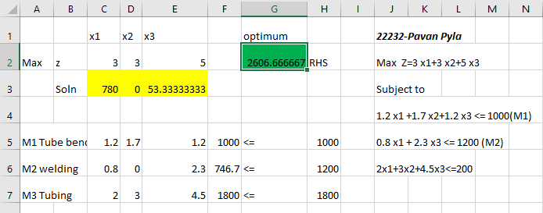

The profit he earns by selling is **2606.66667.** He lost 2766.66667-2606.666667=**160$**

But he earns 200*1.5=**300** from buyer, so it is recommendable.

OUTDOOR INC. will get profit of **140**

***10.If the contribution on chairs were to decrease to $2.50, what would be the optimal production mix and what contribution would this production plan give?***

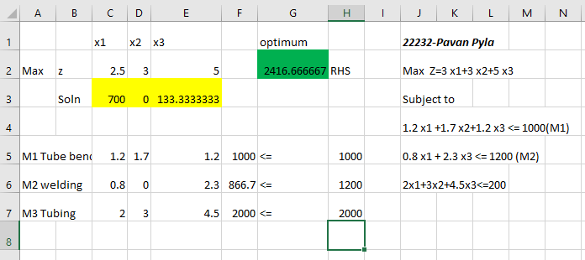

If the Constribution of chairs decreased to 2.5$ ,then the optimal production mix

Goes like this and profit we get reduced to **2416.66667**